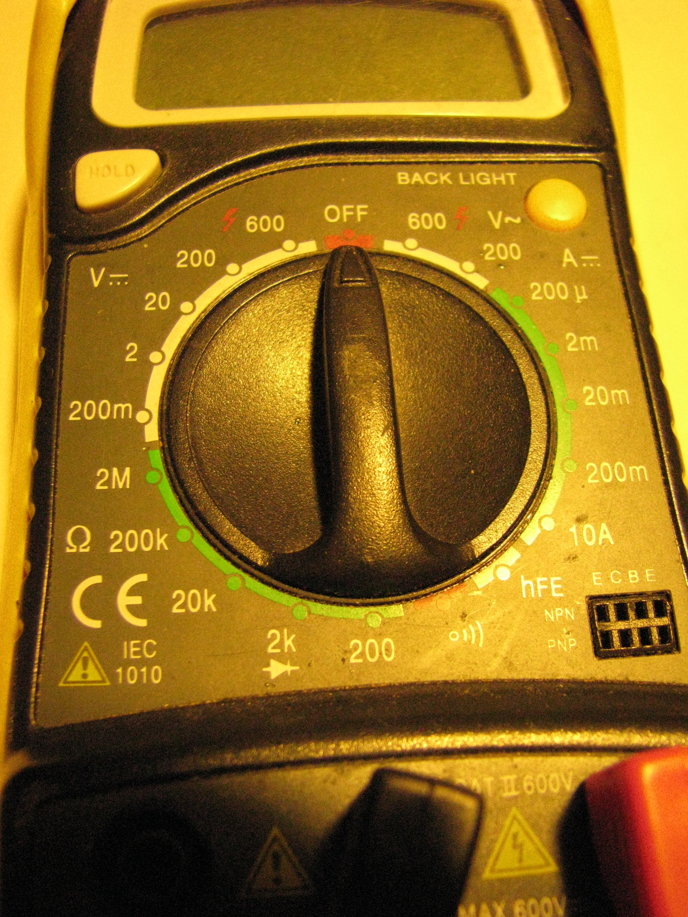
Principles of Technology
Exam F09
Student Name:
Section 1: Circuits and CD drive Junkbot 15 points
In this course, you used the multimeter for a variety of tests on objects and circuits.
Below, you see an image of a meter. Label the following by putting the correct letter after the term:
1. Resistance or Ohms,
2. Volts DC,
3 Continuity
A B

C D

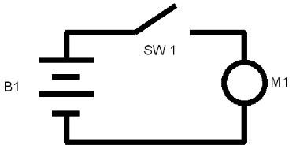
(Ask if you want to see an actual meter)
3. What does this circuit do?

4. How could you change the direction of M1?

5. How could you make M1 go faster or slower?

Section 2: Vinyl cutter file preparation 15 points
6. Using Open Office and Gimp, make a 2 inch by 3 inch design that could be used to cut a sticker. You can use the image of your choice.
Put your name next to the image and print the image
Email a copy of the image to yourself.
If you would like to cut the image, you can do so if there is time in the exam, or you can stay during the break time in exams.

Section 3: Cigar box speaker system 15 points
7.. Provide a link to your documentation of the speaker box on the web. Paste it on the line below:
8. When you are soldering two wires together, you should:
a Heat the solder on the iron and drop it onto the two wires
b Melt the insulation off with the soldering iron
c Heat up the two wires and touch the solder to the hot wires
d
9. The cigar box speaker system will work equally well on batteries or a wall transformer.
Section 4: Mendocino Motor Sketchup 15 points
10. Make the Mendocino Motor base: the base is 9 inches by 4 inches with grooves of ½ inch located at 2 ½ inches from the ends.
Save the file, add it to your Ning blog
Add a link to this document on the line below

Section 5: Mendocino Motor Build 15 points
11. When light hits the solar cells, the light is converted to ______________.
12. A coil of wire, when connected in an electric circuit becomes a/an _____________.
13. Describe the importance and technique of carefully placing the magnets on the base and rotor.
Section 6: Open Response: 25 points
Electricity and circuits
14. Explain what have you learned about working with electricity and circuits in this course. Tell how you have used or could use this information outside of class.

Modifying and hacking devices
In this course, you have had the opportunity to hack everyday objects such as: cigar boxes, cardboard, computer cd drives, computer speakers and computer speaker systems and other electrical components.

15. Reflect on modifying and hacking devices, use the questions below to guide your writing.
What has this experience shown you about the workings of these devices?
What do you see in the junk around you that could be repurposed?
How has this experience affected the projects that you have done recently on your own or consider doing in the future?

